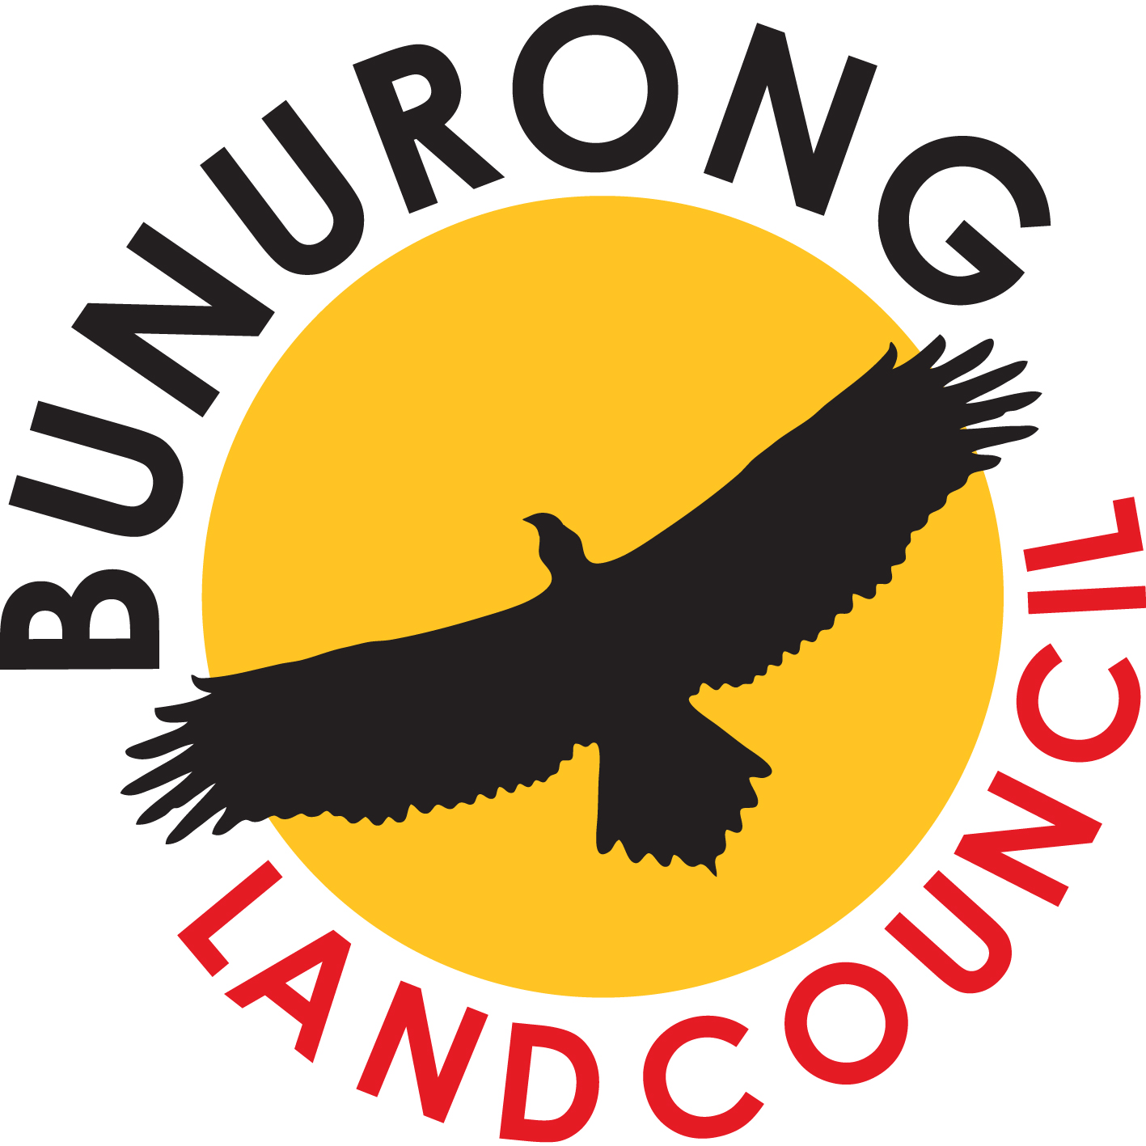

ABN: 66 129 413 297 ICN: 3630

PO Box 4128, Frankston Heights VIC 3199

Ph:0499 222 331 Fax: 02 6921 9455

www.bunuronglc.org

REQUEST FOR BUNURONG REPRESENTATIVE

Project Number:
CHMP No:
Cultural Heritage Advisor(s) CHA:
Mobile:
Nature of activity:
Job Location:
Meeting Location:
Number of Reps required:
Date(s) Required:
Daily reporting time:
Induction Time (if required)
Safety Requirements and
Personal Protective Equipment (PPE)
Sponsor/client:
Billing Details
Attention:

Address:

Email:

Phone

Mobile:

Fax:

Please send bookings for BLCAC field reps to Rob at heritagemanager@bunuronglc.org.au or you can contact Rob on 0455 559 727 for anything relating to rep bookings, cancellations, alterations, postponements, changes to invoicing details/start times or meeting places, booking forms and confirmations.

